Supplementary materials

Slowly but surely: Larger brains improve immature survival in primates

Zitan Song^{1*} & Carel P. van Schaik^{1, 2, 3}

Table S1.
Data on body mass, brain mass, age at first reproduction and immature survival of female primates in 18 species living in natural, non-provisioned populations.

Genus | Species | Bo ADF (kg) | Br ADF (g) | AFR (yr) | Surv -AFR | Surv-1st yr | Source (references and footnotes)
Propithecus | diadema edwardsii | 5.5 | 38.3 | 5.5 | 0.2 | 0.5 | Ranomafana from Pochron et al. 2004
Propithecus | verreauxi | 3.2 | 26.2 | 5.0 | 0.22 | 0.55 | Kirindy from Kappeler & Fichtel 2012 (1)
Lemur | catta | 2.2 | 22.1 | 3.23 | 0.20 | 0.48 | Beza from Gould et al. 2003 (2)
Alouatta | palliata | 5.35 | 51.2 | 4.0 | 0.35 | 0.74 | BCI from Fröhlich et al. 1981
Alouatta | seniculus | 5.2 | 55.4 | 5.1 | 0.35 | 0.79 | Hato Masaguaral from Crockett, in Table in Robinson 1988
Cebus | capucinus | 2.3 | 69 | 6.5 | 0.63 | 0.79 | Lomas from Bronikowski et al. 2016
Cebus | nigritus | 2.5 | 64.2 | 6.4 | 0.58 | 0.70 | Iguazu from Janson et al. 2012; AFR from Di Bitetti & Janson 2001 (3)
Cebus | olivaceus | 2.5 | 64.2 | 7.0 | 0.61 | 0.82 | Hato Masaguaral from Robinson 1988 (4).
Brachyteles | arachnoides | 8.33 | 119.4 | 8.5 | 0.61 | 0.95 | Montes Claros from Bronikowski et al. (2016); AFR from Martins & Strier 2004; brain from Burger et al. 2019
Presbytis | thomasi | 6.7 | 57.7 | 5.4 | 0.3 | 0.54 | Ketambe from Wich et al. 2007 (5)
Cercopithecus | mitis | 4.2 | 66 | 7.5 | 0.67 | 0.86 | Kakamega from Bronikowski et al. 2016
Papio | cynocephalus | 12.8 | 150 | 5.5 | 0.57 | 0.77 | Amboseli from Bronikowski et al. 2016
Macaca | fascicularis | 3.5 | 63.2 | 5.2 | 0.62 | 0.81 | Ketambe from van Noordwijk & van Schaik 1999
Macaca | fuscata | 8.03 | 96.8 | 6.1 | 0.58 | 0.75 | Yakushima, from Takahata et al. 1998
Hylobates | lar | 5.4 | 101.5 | 10.5 | 0.53 | 0.89 | Reichard & Barelli 2008; Reichard et al. 2012. (6)
Gorilla | beringei | 95 | 433 | 9.5 | 0.61 | 0.79 | Karisoke from Bronikowski et al. 2016
Pongo | pygmaeus | 35.5 | 338 | 14.8 | 0.91 | 0.98 | van Noordwijk et al. 2018
Pan | troglodytes | 34 | 357 | 14.0 | 0.7 | 0.83 | Wood et al. 2017; AFR from Robson et al. 2006 (7)

Bo ADF = adult female body mass; Br ADF = adult female brain mass; AFR = age at first reproduction
Footnotes
(1) Brain size taken from species mean value. We selected Kirindy rather than Beza because it has natural predators.
(2) Survival to AFR is a rather crude estimate.
(3) Body and brain from Cebus apella (closest relative, since robust, tufted capuchin).
(4) Brain mass from Cebus (Sapajus) apella, which is closest in weight.
(5) We took brain size from P. melalophos- its geographic sister species.
(6) Survival to AFR is average between 0.46 reported by Reichard & Barelli 2008 and 0.60 reconstructed from Reichard et al. 2012.
(7) We took Ngogo because it is least affected by (human-introduced) disease and has no declining population.
References
Pochron, S. T., Tucker, W. T., & Wright, P. C. (2004). Demography, life history, and social structure in Propithecus diadema edwardsi from 1986–2000 in Ranomafana National Park, Madagascar. American Journal of Physical Anthropology: The Official Publication of the American Association of Physical Anthropologists, 125(1), 61-72.
Kappeler, P. M., & Fichtel, C. (2012). A 15-year perspective on the social organization and life history of sifaka in Kirindy Forest. Long-term field studies of primates, 101-121.
Gould, L., Sussman, R. W., & Sauther, M. L. (2003). Demographic and life‐history patterns in a population of ring‐tailed lemurs (Lemur catta) at Beza Mahafaly Reserve, Madagascar: a 15‐year perspective. American Journal of Physical Anthropology: The Official Publication of the American Association of Physical Anthropologists, 120(2), 182-194.
Froehlich, J. W., Thorington, R. W., & Otis, J. S. (1981). The demography of howler monkeys (Alouatta palliata) on Barro Colorado Island, Panama. International Journal of Primatology, 2, 207-236.
Robinson, J. G. (1988). Demography and group structure in wedge-capped capuchin monkeys, Cebus olivaceus. Behaviour, 104(3-4), 202-232.
Bronikowski, A. M., Cords, M., Alberts, S. C., Altmann, J., Brockman, D. K., Fedigan, L. M., ... & Morris, W. F. (2016). Female and male life tables for seven wild primate species. Scientific data, 3(1), 1-8.
Janson, C., Baldovino, M. C., & Di Bitetti, M. (2012). The group life cycle and demography of brown capuchin monkeys (Cebus apella nigritus) in Iguazú National Park, Argentina. Long-term field studies of primates, 185-212.
Di Bitetti, M. S., & Janson, C. H. (2001). Reproductive socioecology of tufted capuchins (Cebus apella nigritus) in northeastern Argentina. International Journal of Primatology, 22, 127-142.
Martins, W. P., & Strier, K. B. (2004). Age at first reproduction in philopatric female muriquis (Brachyteles arachnoides hypoxanthus). Primates, 45, 63-67.
Burger, J. R., George Jr, M. A., Leadbetter, C., & Shaikh, F. (2019). The allometry of brain size in mammals. Journal of Mammalogy, 100(2), 276-283.
Wich, S. A., Steenbeek, R., Sterck, E. H., Korstjens, A. H., Willems, E. P., & Van Schaik, C. P. (2007). Demography and life history of Thomas langurs (Presbytis thomasi). American Journal of Primatology: Official Journal of the American Society of Primatologists, 69(6), 641-651.
van Noordwijk, M. A., & van Schaik, C. P. (1999). The effects of dominance rank and group size on female lifetime reproductive success in wild long-tailed macaques, Macaca fascicularis. Primates, 40, 105-130.
Takahata, Y., Suzuki, S., Agetsuma, N., Okayasu, N., Sugiura, H., Takahashi, H., ... & Sprague, D. S. (1998). Reproduction of wild Japanese macaque females of Yakushima and Kinkazan Islands: a preliminary report. Primates, 39, 339-349.
Reichard, U. H., & Barelli, C. (2008). Life history and reproductive strategies of Khao Yai Hylobates lar: implications for social evolution in apes. International Journal of Primatology, 29, 823-844.
Reichard, U. H., Ganpanakngan, M., & Barelli, C. (2012). White-handed gibbons of Khao Yai: social flexibility, complex reproductive strategies, and a slow life history. Long-term field studies of primates, 237-258.
van Noordwijk, M. A., Atmoko, S. S. U., Knott, C. D., Kuze, N., Morrogh-Bernard, H. C., Oram, F., ... & Willems, E. P. (2018). The slow ape: High infant survival and long interbirth intervals in wild orangutans. Journal of Human Evolution, 125, 38-49.
Wood, B. M., Watts, D. P., Mitani, J. C., & Langergraber, K. E. (2017). Favorable ecological circumstances promote life expectancy in chimpanzees similar to that of human hunter-gatherers. Journal of Human Evolution, 105, 41-56.
Robson, S. L., Van Schaik, C. P., & Hawkes, K. (2006). The derived features of human life history. The evolution of human life history, Eds Hawkes, K & Paine, RR, 17-44, School of American Research Press.

Table S2.
Model selection results from phylogenetic path analysis. Each candidate model was evaluated using Fisher’s C test and ranked by the C-statistic Information Criterion corrected for small sample size (CICc). Model structures are shown in Figure S1.

Models | k | q | Fisher’s C | p | CICc | Delta CICc | weight
Brain (log)
m5_4 | 2 | 8 | 4.411 | 0.353 | 36.411 | 0.000 | 0.712
m3_4 | 2 | 8 | 8.867 | 0.065 | 40.867 | 4.455 | 0.077
m1_4 | 1 | 9 | 1.594 | 0.451 | 42.094 | 5.682 | 0.042
m4_4 | 1 | 9 | 1.594 | 0.451 | 42.094 | 5.682 | 0.042
m6_4 | 1 | 9 | 1.594 | 0.451 | 42.094 | 5.682 | 0.042
m5_3 | 3 | 7 | 17.052 | 0.009 | 42.252 | 5.841 | 0.038
m2_4 | 2 | 8 | 13.739 | 0.008 | 45.739 | 9.327 | 0.007
m7_4 | 2 | 8 | 13.739 | 0.008 | 45.739 | 9.327 | 0.007
m1_3 | 2 | 8 | 14.235 | 0.007 | 46.235 | 9.823 | 0.005
m4_3 | 2 | 8 | 14.235 | 0.007 | 46.235 | 9.823 | 0.005
m6_3 | 2 | 8 | 14.235 | 0.007 | 46.235 | 9.823 | 0.005
m3_3 | 3 | 7 | 21.507 | 0.001 | 46.707 | 10.296 | 0.004
m5_5 | 2 | 8 | 14.752 | 0.005 | 46.752 | 10.341 | 0.004
m1_1 | 2 | 8 | 16.183 | 0.003 | 48.183 | 11.771 | 0.002
m4_1 | 2 | 8 | 16.183 | 0.003 | 48.183 | 11.771 | 0.002
m5_6 | 2 | 8 | 16.536 | 0.002 | 48.536 | 12.124 | 0.002
m5_1 | 3 | 7 | 23.759 | 0.001 | 48.959 | 12.548 | 0.001
m6_1 | 2 | 8 | 18.288 | 0.001 | 50.288 | 13.877 | 0.001
m5_2 | 3 | 7 | 25.985 | 0.000 | 51.185 | 14.774 | 0.000
m3_5 | 2 | 8 | 19.207 | 0.001 | 51.207 | 14.796 | 0.000
m2_3 | 3 | 7 | 26.379 | 0.000 | 51.579 | 15.168 | 0.000
m7_3 | 3 | 7 | 26.379 | 0.000 | 51.579 | 15.168 | 0.000
m1_5 | 1 | 9 | 11.935 | 0.003 | 52.435 | 16.023 | 0.000
m4_5 | 1 | 9 | 11.935 | 0.003 | 52.435 | 16.023 | 0.000
m6_5 | 1 | 9 | 11.935 | 0.003 | 52.435 | 16.023 | 0.000
m3_6 | 2 | 8 | 20.991 | 0.000 | 52.991 | 16.580 | 0.000
m3_1 | 3 | 7 | 28.215 | 0.000 | 53.415 | 17.003 | 0.000
m2_1 | 3 | 7 | 28.327 | 0.000 | 53.527 | 17.116 | 0.000
m1_6 | 1 | 9 | 13.718 | 0.001 | 54.218 | 17.807 | 0.000
m4_6 | 1 | 9 | 13.718 | 0.001 | 54.218 | 17.807 | 0.000
m6_6 | 1 | 9 | 13.718 | 0.001 | 54.218 | 17.807 | 0.000
m4_2 | 2 | 8 | 23.168 | 0.000 | 55.168 | 18.756 | 0.000
m6_2 | 2 | 8 | 23.168 | 0.000 | 55.168 | 18.756 | 0.000
m7_1 | 3 | 7 | 30.433 | 0.000 | 55.633 | 19.221 | 0.000
m2_5 | 2 | 8 | 24.080 | 0.000 | 56.080 | 19.668 | 0.000
m7_5 | 2 | 8 | 24.080 | 0.000 | 56.080 | 19.668 | 0.000
m2_6 | 2 | 8 | 25.863 | 0.000 | 57.863 | 21.452 | 0.000
m7_6 | 2 | 8 | 25.863 | 0.000 | 57.863 | 21.452 | 0.000
m1_2 | 2 | 8 | 26.332 | 0.000 | 58.332 | 21.921 | 0.000
m3_2 | 3 | 7 | 33.605 | 0.000 | 58.805 | 22.394 | 0.000
m2_2 | 3 | 7 | 46.333 | 0.000 | 71.533 | 35.121 | 0.000
m7_2 | 3 | 7 | 46.333 | 0.000 | 71.533 | 35.121 | 0.000
Brain (residual)
m5_4 | 2 | 8 | 4.411 | 0.353 | 36.411 | 0.000 | 0.665
m5_5 | 2 | 8 | 8.201 | 0.084 | 40.201 | 3.789 | 0.100
m1_4 | 1 | 9 | 1.594 | 0.451 | 42.094 | 5.682 | 0.039
m4_4 | 1 | 9 | 1.594 | 0.451 | 42.094 | 5.682 | 0.039
m6_4 | 1 | 9 | 1.594 | 0.451 | 42.094 | 5.682 | 0.039
m5_3 | 3 | 7 | 17.052 | 0.009 | 42.252 | 5.841 | 0.036
m3_4 | 2 | 8 | 11.126 | 0.025 | 43.126 | 6.714 | 0.023
m2_4 | 2 | 8 | 13.739 | 0.008 | 45.739 | 9.327 | 0.006
m7_4 | 2 | 8 | 13.739 | 0.008 | 45.739 | 9.327 | 0.006
m1_5 | 1 | 9 | 5.383 | 0.068 | 45.883 | 9.472 | 0.006
m4_5 | 1 | 9 | 5.383 | 0.068 | 45.883 | 9.472 | 0.006
m6_5 | 1 | 9 | 5.383 | 0.068 | 45.883 | 9.472 | 0.006
m1_3 | 2 | 8 | 14.235 | 0.007 | 46.235 | 9.823 | 0.005
m4_3 | 2 | 8 | 14.235 | 0.007 | 46.235 | 9.823 | 0.005
m6_3 | 2 | 8 | 14.235 | 0.007 | 46.235 | 9.823 | 0.005
m3_5 | 2 | 8 | 14.915 | 0.005 | 46.915 | 10.504 | 0.003
m1_1 | 2 | 8 | 16.101 | 0.003 | 48.101 | 11.690 | 0.002
m4_1 | 2 | 8 | 16.101 | 0.003 | 48.101 | 11.690 | 0.002
m5_6 | 2 | 8 | 16.536 | 0.002 | 48.536 | 12.124 | 0.002
m6_1 | 2 | 8 | 16.651 | 0.002 | 48.651 | 12.240 | 0.001
m3_3 | 3 | 7 | 23.766 | 0.001 | 48.966 | 12.555 | 0.001
m2_5 | 2 | 8 | 17.528 | 0.002 | 49.528 | 13.117 | 0.001
m7_5 | 2 | 8 | 17.528 | 0.002 | 49.528 | 13.117 | 0.001
m5_2 | 3 | 7 | 25.985 | 0.000 | 51.185 | 14.774 | 0.000
m2_3 | 3 | 7 | 26.379 | 0.000 | 51.579 | 15.168 | 0.000
m7_3 | 3 | 7 | 26.379 | 0.000 | 51.579 | 15.168 | 0.000
m2_1 | 3 | 7 | 28.246 | 0.000 | 53.446 | 17.034 | 0.000
m5_1 | 3 | 7 | 28.592 | 0.000 | 53.792 | 17.381 | 0.000
m7_1 | 3 | 7 | 28.796 | 0.000 | 53.996 | 17.584 | 0.000
m1_6 | 1 | 9 | 13.718 | 0.001 | 54.218 | 17.807 | 0.000
m4_6 | 1 | 9 | 13.718 | 0.001 | 54.218 | 17.807 | 0.000
m6_6 | 1 | 9 | 13.718 | 0.001 | 54.218 | 17.807 | 0.000
m4_2 | 2 | 8 | 23.168 | 0.000 | 55.168 | 18.756 | 0.000
m6_2 | 2 | 8 | 23.168 | 0.000 | 55.168 | 18.756 | 0.000
m3_6 | 2 | 8 | 23.250 | 0.000 | 55.250 | 18.839 | 0.000
m2_6 | 2 | 8 | 25.863 | 0.000 | 57.863 | 21.452 | 0.000
m7_6 | 2 | 8 | 25.863 | 0.000 | 57.863 | 21.452 | 0.000
m1_2 | 2 | 8 | 26.332 | 0.000 | 58.332 | 21.921 | 0.000
m3_1 | 3 | 7 | 35.306 | 0.000 | 60.506 | 24.095 | 0.000
m3_2 | 3 | 7 | 35.864 | 0.000 | 61.064 | 24.653 | 0.000
m2_2 | 3 | 7 | 46.333 | 0.000 | 71.533 | 35.121 | 0.000
m7_2 | 3 | 7 | 46.333 | 0.000 | 71.533 | 35.121 | 0.000
k= number of independence claims; q= number of parameters

Table S3.
Effect of brain mass (residual) and max adult life span (max life span - AFR) on a) S_{A} (survival rate until female AFR), and b) S₁ (survival rate until age 1).
 | Estimate | se | t | p
a) Survival rate until AFR (S_{A}) with absolute brain size
Intercept | -0.194 | 0.508 | -0.382 | 0.708
Brain mass (residual) | 0.587 | 0.226 | 2.593 | 0.020*
max adult life span (log) | 0.075 | 0.210 | 0.357 | 0.726
b) Survival rate until age 1 (S₁) with absolute brain size
Intercept | -0.151 | 0.569 | -0.266 | 0.794
Brain mass (residual) | 0.777 | 0.275 | 2.831 | 0.013*
max adult life span (log) | -0.254 | 0.257 | -0.985 | 0.340
Maximum adult lifespan (in years) was primarily obtained from Isler and van Schaik (2012; DOI: 10.1016/j.jhevol.2012.03.009), except for Gorilla beringei, which was sourced from Myhrvold et al. (2015; DOI: 10.1890/15-0846R.1).

Figure
Figure S1
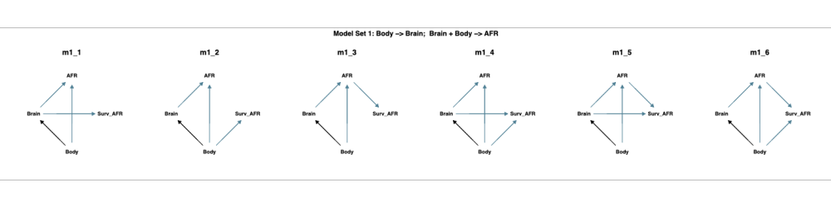
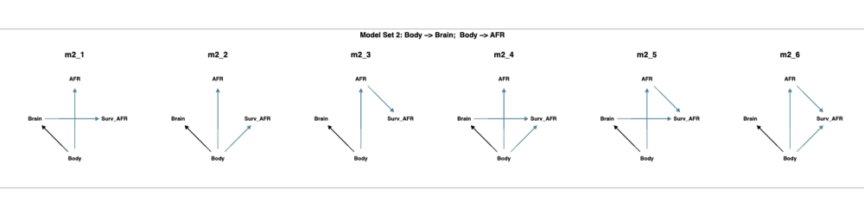
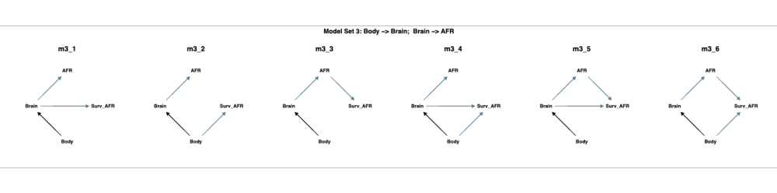
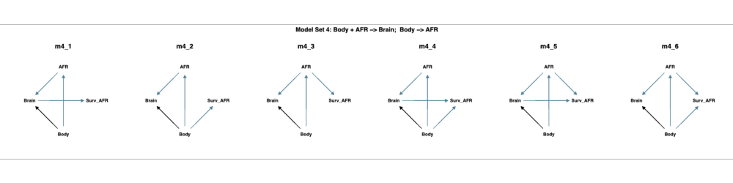
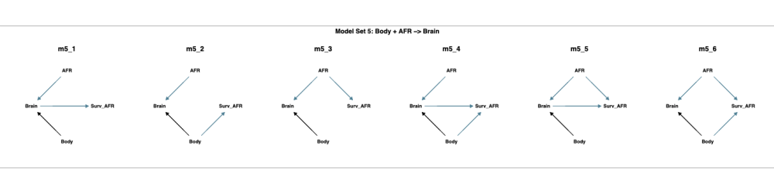
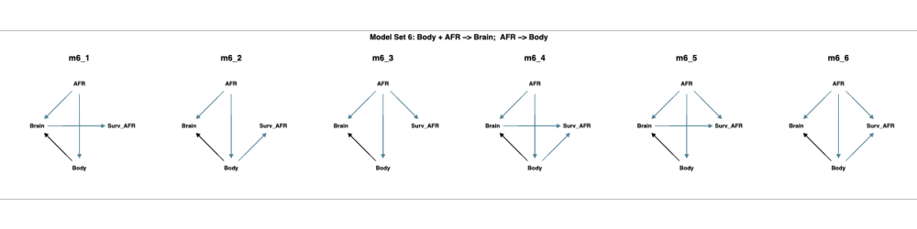
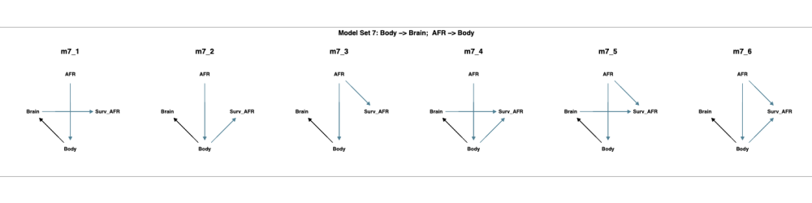
Figure S1. 42 candidate path models were tested using phylogenetic path analysis to explore the relationships among body size, brain size, age at first reproduction (AFR), and survival until AFR (Surv_AFR). Models were evaluated based on d-separation tests, with overall fit quantified using Fisher’s C statistic and ranked using CICc.

